An advisory commission of the Coastal Protection and Restoration Authority
cOASTAL LOUISIANA LEVEE CONSORTIUM

Amite River Basin Drainage and Water Conservation District

Atchafalaya Basin Levee District

Office of the Governor-Coastal Activities

Chenier Plain Coastal Restoration & Protection Authority

Grand Isle Independent Levee District

Iberia Parish Levee District

Jefferson Davis Parish Government

Lafitte Area Independent Levee District

Lafourche Basin Levee District

Non-Flood Protection Asset Management Authority

North Lafourche Conservation, Levee and Drainage District

Plaquemines Parish Government

Pontchartrain Levee District

The Sewerage and Water Board of New Orleans

South Lafourche Levee District

Southeast Louisiana Flood Protection Authority—East

Southeast Louisiana Flood Protection Authority—West

St. Mary Levee District

St. Tammany Levee District

Terrebonne Levee and Conservation District

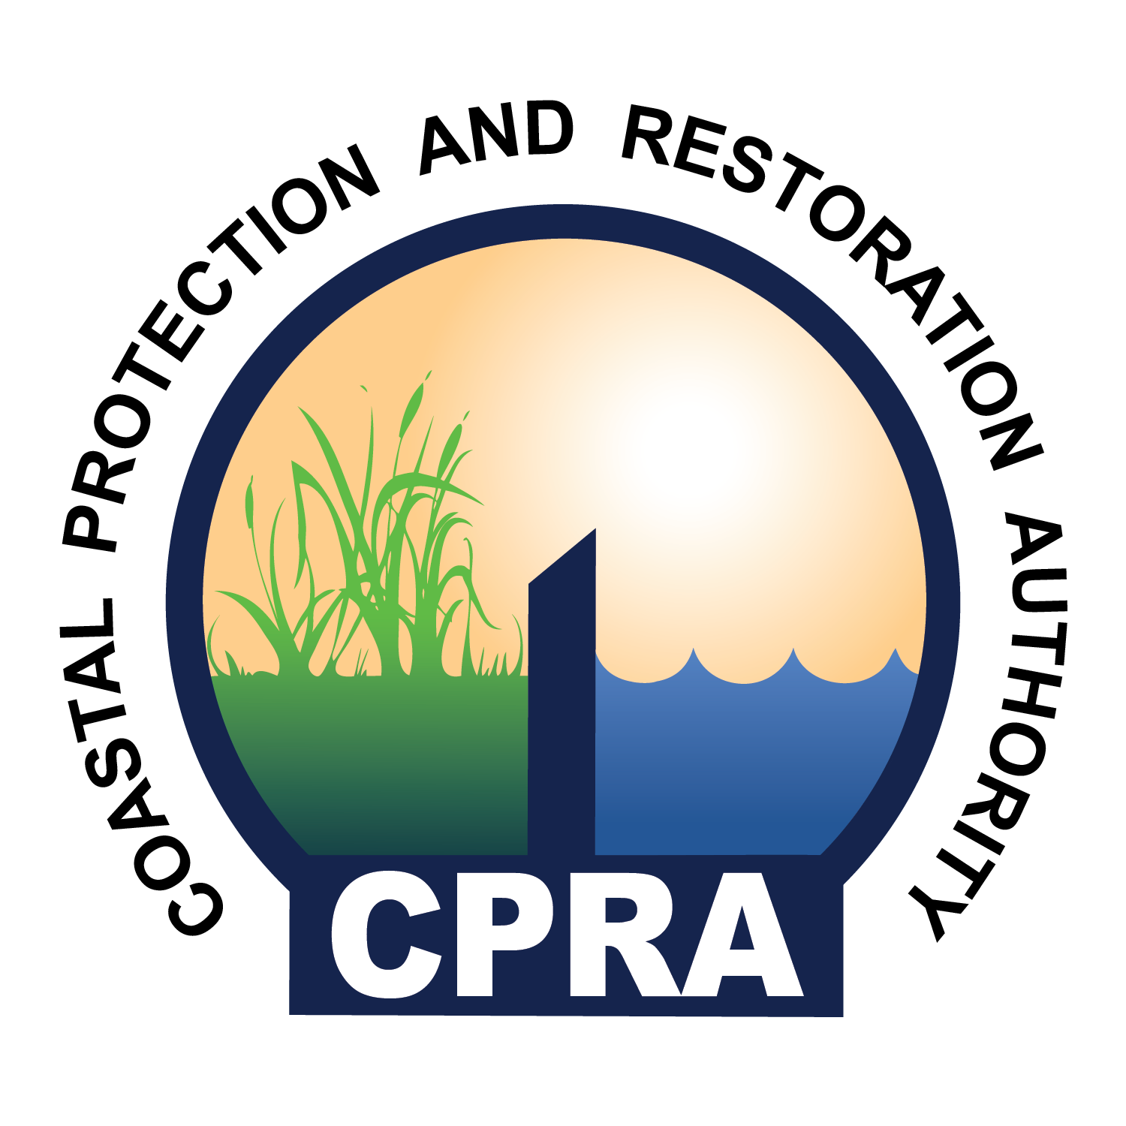

Rev: 00.2017

Coastal Louisiana Levee Consortium Meeting
Galvez Building (DEQ) – Oliver Pollock Room
602 North 5th Street
Baton Rouge, LA 70802

April 25, 2017
1:30 P.M. – 3:00 P.M.

- Call to Order – Windell Curole
- Roll Call
- Approval of Agenda
- Approval of Minutes
- Key legislative items affecting levee district operations – Reggie Dupre
HR 1 | Approves the annual integrated coastal protection plan for Fiscal Year 2018, as adopted by the CPRA.
SB 249 | Dedicates certain revenue received by the state from the federal government via the Gulf of Mexico Energy and Security Act.
HB 438 | Authorizes flood protection authority spending across the various levee districts.
HB 234 | Provides relative to the local match requirements for non-state entities applying for capital outlay funding.
HB 144 | Provides for real property interests for integrated coastal restoration projects.

Other legislative items that may be discussed include the following:
SB 199 | Allows public entities to borrow public equipment from each other without compensation
SCR 1(1) | Approves the comprehensive master plan for integrated coastal protection. April 10, 2017 at 12:00 P.M.
SR 1 (1) | Approves the annual integrated coastal protection plan for Fiscal Year 2018.
HB 596 (1) | Provides relative to the contracting authority of the CPRA.
HB 618 (1) | Authorizes the CPRA to finance payments from the RESTORE Act and Natural Resources Damages Act.
HB 236 (1) | Constitutional Amendment to eliminate certain constitutional dedication of revenue and certain treasury funds.
HB 259 (1) | Constitutional Amendment to provide relative to the taxing authority of levee districts.
HB 266 | Provides for term limits for members of the nominating committee of certain flood protection authorities.
Additional legislative items not listed may be discussed.
- Update on National Flood Insurance Program 5-year renewal – Dwayne Bourgeois
- Public Comment
- Adjourn

